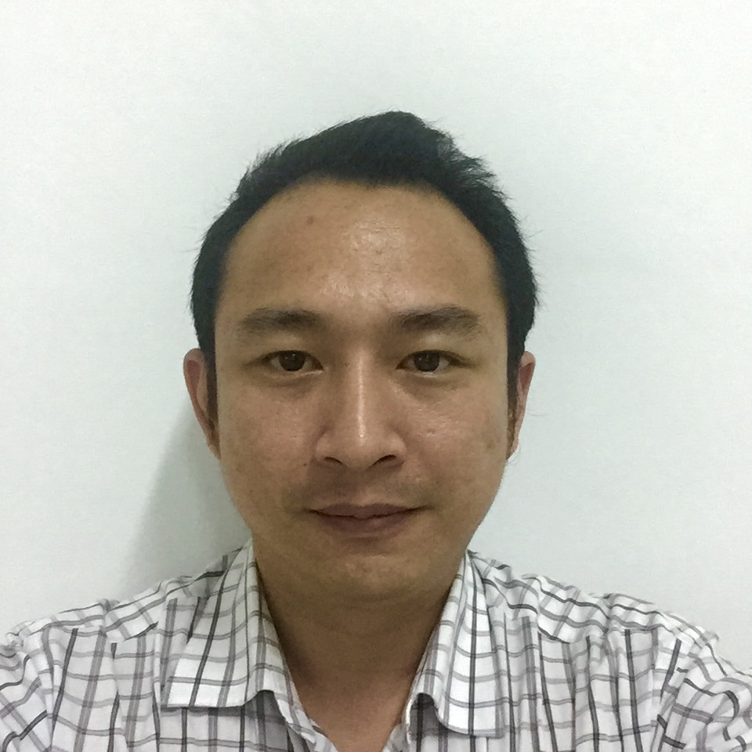

CURRICULUM VITAE

A. PERSONAL INFORMATION

- Full Name : Christian Lisangan
- Place and Date of Birth : Malang-Indonesia, December 25, 1980
- Sex : Male
- Marital Status : Married
- Religion : Catholic
- Status : Singapore Citizen
- IC Number : S8061484E
- Address : Blk 242 Bukit Batok East Ave 5
#05-192, Singapore 650242
- Cellular Phone Number : +65-90608488
- Home Phone Number : +65-67293518
- E-mail Address : christian_lie80@hotmail.com

PROFILE
Experienced Professional with ten years experiences of General Accounting/Auditing and Business Operational Management. I am a self-starter and quick learner, recognized skills in mentoring and mediating between employees, and in leading team tasks.

CAREER OBJECTIVE
To pursue a profession in the Finance/Operational area where ensure supervision, management, and analytical skills are superior.

AREA OF EXPERTISE
- Financial Analysis | - Financial Reporting | - GST Reporting
- CPF Process and Calculating | - LC Process | - Claim Processing
- Audit Procedures

COMPUTER AND TECHNICAL SKILL
- Microsoft Office
- ACCPro (AAPR4) Accounting System
- SAP (Minor)
- Sealing Solution for Pump
- MYOB

B. EDUCATION BACKGROUND

Tarumanagara University, 2001-2006
Jakarta, Indonesia
Majored in Accounting, minored in auditing
Bachelor Degree

C. WORK EXPERIENCE

1. January 2006 – Augustus 2008
Company : Johan Malonda Astika & Rekan, Public Accounting Firm,
(Member of Baker Tilly International)
Address : Jl. Pluit Raya 200 blok V no 1-5 Jakarta Utara, Indonesia 14450
Position Title : January 2006 – July 2006 Technical Assistant
August 2006 – January 2007 Assistant Team Leader
February 2007 – November 2007 Team Leader
December 2007 – August 2008 Account Holder (Senior Audit)
Responsibility :
- Participated in certified audit of clients in fields of trading, packaging, CMT & Textile Export, Manufacturing, Assembling & Electronic Product Sales, Cement, Freight Forwarding Service, Oil palm, Coal Mining, Etc.
- Responsible for the review consisting of analysis, verification, and confirmation. The review provided management with assurance that effective controls and policies were being administrated.
- Preparation of financial reports and statements, and consolidation.
- Responsible for Review and Compilation Services.
- Responsible for whole engagements with limited supervision.
- Management advisory services for clients.
Achievement:
- Entrusted to supervise and managing a team of Audit Assistants within one year of hire.

2. October 2008 – Present
Company : Pitman Technologies Pte Ltd
Address : 105 Sophia Road #02-01, Casa Sophia, Singapore 228170
Position : Operation Manager & Accountant
Current Salary : S$ 2,500.00
Responsibility
- Responsible of handling full sets of accounts and preparation of monthly financial closing.
- Processing payments to suppliers and staff claims.
- Tracking and ensuring prompt payment by customers.
- Maintaining proper accounting records in ERP system and carry out periodic reconciliation.
- Responsible of the GST preparation.
- Responsible for year-end audit preparation.
- Participated in financial planning and cash flow reporting.
- Preparing Quotation, Purchase Order and Invoice.
- Preparing and submission monthly CPF contribution.
- Preparing and submission LC transaction.
- Liaise with bank and Corporate Secretary.
- Liaise with Indonesia Embassy for Trade Agreement & LC process.
- Marketing, Measuring & installation product at Shell Eastern Petroleum (Pte) Ltd.
- Ensure required process for Quality Management System (QMS) is being implemented in the Company.
- Report to Top Management, with regards to result of QMS that has been implemented, and together with all the related development.
- Ensure improvement on self-awareness towards costumers’ requirement from all the personals that have responsibility to QMS.
- Ensure Information or data of company remain secret and confidential.
- Ensure compliance to HSE program.
Achievement:
- Reduce unnecessary cost and expenses Company
- Leading team and ensure all progress work in line and follow HSE program
- Finishing all jobs in time either internal or External jobs

3. April 2016 – Present
Company : MNG Management Services Pte Ltd
Address : 2 Kallang Pudding Road #08-12, Mactech Building, Singapore 349307
Position : Finance & Accountant Services
Current Salary : S$ 1,500.00
Responsibility
- Processing record full sets of accounts data client.
- Preparing Quarterly GST submission, Tax & financial year end client report.
- Ensuring all data reporting finish and ready timely.
- Ensuring confidential all data client.
Achievement:
- All data report, prepared in time.
- Assisting and sharing education of financial art to client, whose did not understand on financial record and how to do documentation.

Note: Presently still active work on Pitman Technologies Pte Ltd & MNG Management Services Pte Ltd.

D. TRAINING, LICENSE AND RELATED COURSES

- Audit Training I – III
Johan Malonda Astika & Rekan Public Accountant Firm
- Tax training
Johan Malonda Astika & Rekan Public Accountant Firm
- Driving License Class 3
- Safety Orientation Course (oil/petrochemical)
- Shell Eastern Petroleum (Pte) Ltd Safety Introduction Course
- ISO 9001:2008 Awareness Training
- ISO 9001:2008 Internal Auditor Training

Expected Salary: $ 4,500.00

